I logged in with admin username and password and reached to default page.
Note that Navigation Menu is showing up.

I clicked on “Change the look and functionality of this page” link. And Page tasks tab opens.
Note that selected current language is English.
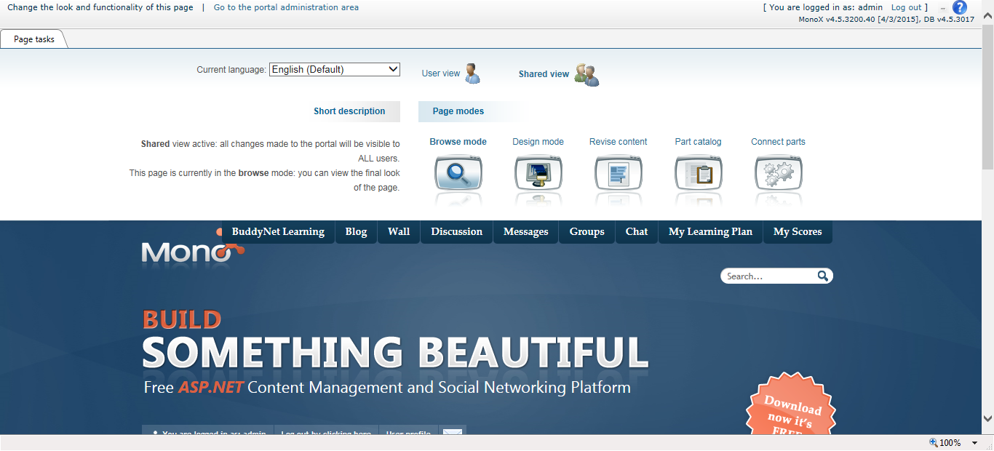

I changed the current language to Spanish.
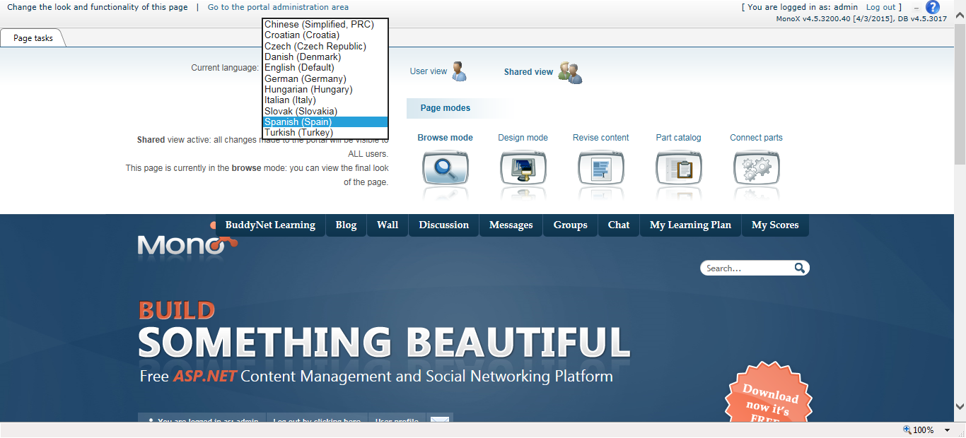

As soon as I choose any other language the Navigation menu goes away.
